Milestone 3: Rest API using Express Framework
Grand Canyon University: CST-391
Benim-Portfolio
Safa Bayraktar
10/14/2021

Abstract
In this milestone, we began to build the REST API of our project in ExpressJS, which is a personal portfolio application for me. Name of the project is a Turkish word meaning “mine” or “my” and all together it means of “my portfolio”. Within this project, I am aiming to create a personal site where I can store all my personal information, projects, links to my social media accounts including GitHub and LinkedIn to easily connect with other developers. I would like to create multiple resumes for different job requirements such as for Cyber Security, Embedded Systems, A.I.s, Data Analysis, and Software Development.

REST API Design Report

User Stories
There is no other than ‘Admin’ in the user stories of this project since it is only going to present me, and my personal information and I am the admin of this project.
As a(n) | I would like to | So that
Admin | Pull all the portfolios from database using API call | I can view content of the portfolios
Admin | Be able to create a portfolio sending an API Post | I can add more portfolios to site without going through database
Admin | Be able to modify/update an existing portfolio sending an API Put | I can manage portfolios on site without going through database
Admin | Be able to delete an existing portfolio sending an API Delete | I can remove portfolios from site without going through database
Admin | Pull all the skills from database using API call | I can view content of the skills associated with a portfolio
Admin | Be able to create skills sending an API Post | I can add more skills to site that are associated with a portfolio without going through database
Admin | Be able to modify/update existing skills sending an API Put | I can manage skills on site without going through database
Admin | Be able to delete existing skills sending an API Delete | I can remove skills from site without going through database

Initial Database Design
This project does not require registration and login features, therefore no need for a user table. These two tables will allow me to create portfolio of my need and add as many skills as I want to.
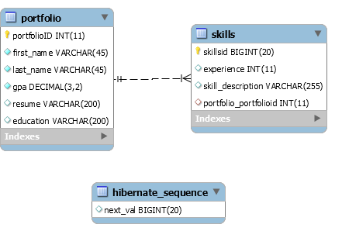
The portfolio table stores the data such as my personal name, my GPA in GCU, link of my uploaded resume, education information. There is one-to-many relationship between `portfolio` and `skills` tables. `skills` tables has a column of primary key coming from `portfolio` table to identify the association of the `skills` table. Lastly, the `hibernate_sequence` is generated by the JPA implementation and not sure if it is necessary to keep it up in the database.

API Documentation
For the API documentation, I used the Swagger to create a template of Benim-Portfolio project. The export of the Swagger documentation is included within the submission.
Swagger Link: https://app.swaggerhub.com/apis/goktan507/Benim-Portfolio/1.0.0#/

Risks
- Lack of knowledge on the Spring Boot Framework
- GitHub’s API implementation to request all the repositories of a given profile

Functionality
Screencast: https://www.loom.com/share/e7915aa36bed4cacba9055c067e7e66d

Code Efficiency
This project is designed using ExpressJS framework. MVC and N-Layer implementation has been applied to this project to organize some of the models, views, and controllers including all the necessary DTO, DAO and business services to act like a bridge in between controllers and DAO services.

References
API Documentation. Swagger. Data retrieved from https://app.swaggerhub.com/home
Screencast demonstration. Loom Video. Data retrieved from https://www.loom.com/

